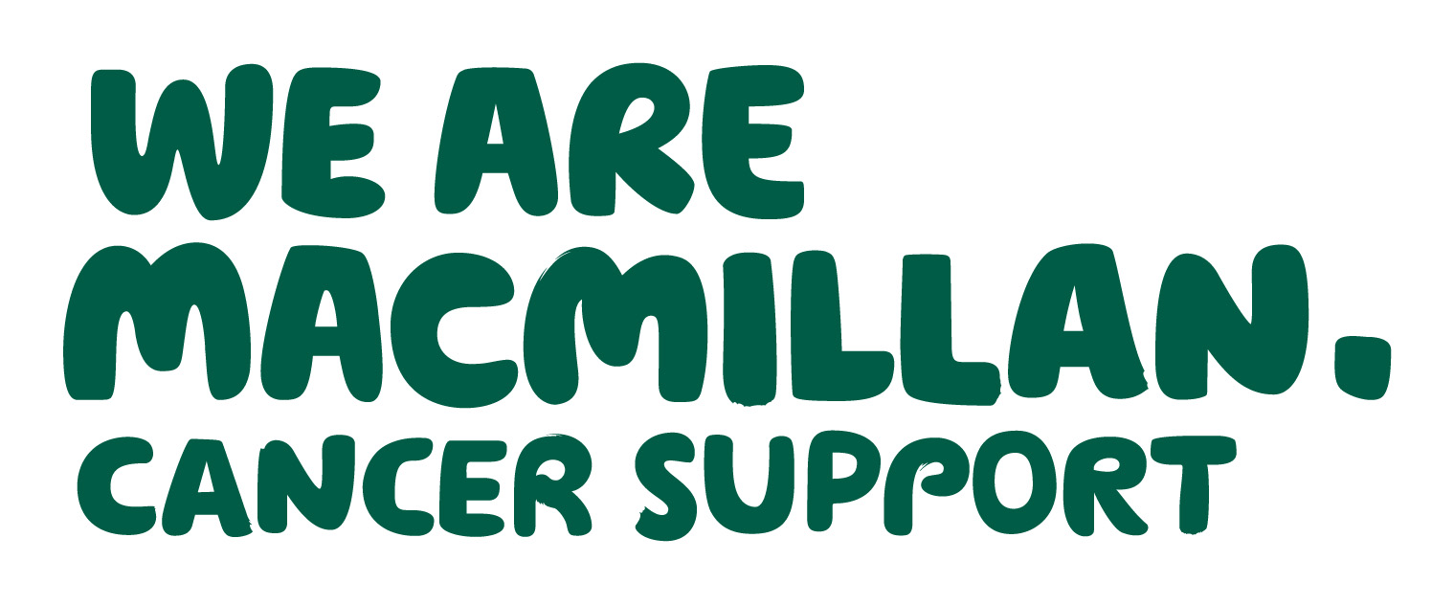 2 MINUTE CANCER UPDATE
November 2019
– keeping you in touch with local and national news
Produced by Dr Gill Clements (Shropshire) and Dr Ellen Nolan (T&W) - your local Macmillan GP facilitators

INTRODUCTION
Welcome to the 2 Minute (or thereabouts depending on the topic!!) Cancer Update. We recognise that GP practices are busy places and that you receive numerous emails and other forms of communication. The aim of this update is therefore to provide bite-sized chunks of information to digest over your tea/coffee break (assuming you still have these!).

LUNG CANCER (source - Macmillan in partnership with Red Whale)
The UK continues to lag significantly behind other European nations in 5- and 10-year survival rates from lung cancer.
We can make earlier diagnosis in primary care by:
- Improving patient awareness of symptoms – ‘Be Clear on Cancer’ has done this.
- Having a low threshold for referring for CXR in at-risk patients – CXRs are cheap, widely available and relatively harm-free
- Not being falsely reassured by negative CXR in patients with persistent symptoms.
Remember, beware the negative CXR – if we still have a degree of suspicion, we should refer!
So, when should we order a chest radiograph?
Lung cancer does not always present with a clear symptom signature, and affected individuals often have comorbidities that could confuse the picture. While haemoptysis is the most predictive isolated symptom, it only occurs in 20% of those with a final diagnosis of lung cancer. Remember more unusual presentations such as thrombocytosis, appetite loss, shoulder pain and worsening spirometry, especially in smokers. NICE offers clear guidance on how we should approach patients presenting with symptoms that could be suggestive of lung cancer.
And remember too that stopping smoking is beneficial at any stage, even after a diagnosis of lung cancer.
Yes, our headline about UK survival rates from lung cancer sounds depressing. But there is hope in the form of screening for earlier detection and evolving innovative immunotherapy-based treatments. Our key challenges in primary care are prevention through smoking cessation, helping patients spot it early and supporting patients through ever-more-complex treatment regimens.

ReSPECT
ReSPECT is now the new DNACPR (see last month’s cancer newsletter for support information). Just a few points to note:
- Current DNACPR forms are still acceptable and there is no timescale to replace all these forms but no new ones should be issued.
- There is no directive to replace all DNACPR forms in care homes with ReSPECT forms.
- ReSPECT forms can be countersigned by senior nurses.
- A ReSPECT form without a counter signature is valid but should be reviewed when possible.
- ReSPECT forms do not have to be completed by GPs nurses and other health care workers are also being trained.

If you have any queries and or concerns please e mail either gill.clements@nhs.net (Shropshire) or ellen.nolan@nhs.net (Telford and Wrekin).

Macmillan helpline for patients 8am-8pm 7 days per week
0808 808 00 00

See Macmillan website www.macmillan.org.uk for a range of useful information eg the “10 Top Tips” series

