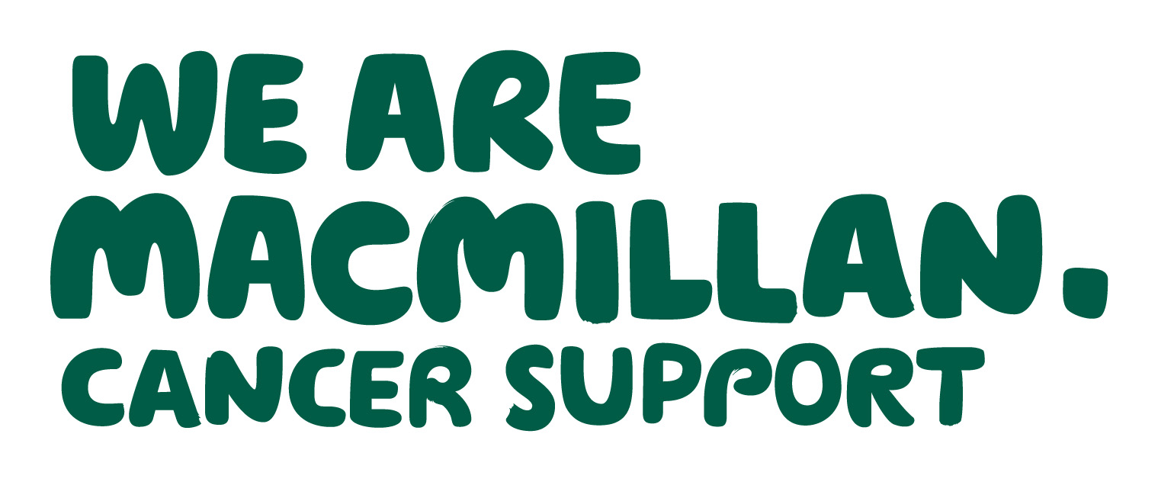 2 MINUTE CANCER UPDATE
October 2019
– keeping you in touch with local and national news
Produced by Dr Gill Clements (Shropshire) and Dr Ellen Nolan (T&W) - your local Macmillan GP facilitators

INTRODUCTION
Welcome to the 2 Minute (or thereabouts depending on the topic!!) Cancer Update. We recognise that GP practices are busy places and that you receive numerous emails and other forms of communication. The aim of this update is therefore to provide bite-sized chunks of information to digest over your tea/coffee break (assuming you still have these!).

ReSPECT – Recommended Summary Plan for Emergency Care and Treatment
A reminder to all that the new ReSPECT form replaces the multiple DNACPR forms in Shropshire and Telford and Wrekin (not Wales) from the 31st October 2019.
You will receive a pack of forms and patient information leaflets this month. They will also be available in EMIS under documents – ideally to be printed in lilac or on lilac paper but black and white is acceptable but less distinct/noticeable. The original form is “owned” by the patient, must be left with them and will travel with them should they be admitted to hospital or other establishment. Ideally a copy should be scanned into the patient’s notes. Please code the form using READ code 8C59 (emergency care plan). This will enable future audit, possibly as part of the new EOL QI work.
Many of you will have attended training or checked on line resources but others may wish to access two particularly helpful sites:
https://www.hacw.nhs.uk/respect/ and www.resus.org.uk/respect
Overleaf are some frequently asked questions.
FOR FURTHER INFORMATION OR REQUESTS TO ATTEND PRACTICE MEETINGS PLEASE CONTACT gill.clements@nhs.net (Shropshire) or ellen.nolan@nhs.net (Telford and Wrekin).
Frequently asked questions
- Who is the ReSPECT form for? – anyone in theory but especially those patients with complex health problems, severe frailty etc and in the last 12 months of life. (Consider using the SPICT guide to identify these patients www.spict.org.uk)

- What is the ReSPECT form? – a summary of a patient’s wishes recorded on a form that includes their personal priorities for care and agreed clinical recommendations about care and treatment that could help achieve the outcome that the patient would want. It may also highlight those interventions that would not help, or that they would not want. The form is to be used in an emergency when a patient is unable to make these decisions.

- Where can I find the form? - there will be an initial supply of the forms sent to every practice but they can also be found in EMIS and Vision under CCG documents.

- Who completes it? – the form can be completed by any health care professional competent to do so and ideally trained in “difficult conversations” but needs to be endorsed by the senior responsible clinician (usually the GP or consultant).

- Where is it kept? – the original form must remain with the patient. Copies can be made and ideally the form should be scanned into the patient’s electronic record.

- Do I have to code the ReSPECT form? Yes; please use the READ code 8C59 (emergency treatment plan) and if the patient is not for resuscitation (having a ReSPECT from does not automatically mean the patient is not for resuscitation), please also code “not for resuscitation”.

- Do I need to flag patients to 111/Shropdoc/ambulance service? – Yes; please using the current system – this remains very important. Although Shropdoc can now access EMIS OOHs 111 and the ambulance service cannot. These services need to be made aware of any ReSPECT forms.

- What happens to current DNACPR forms? – these forms remain valid but no red bordered DNACPR forms should be completed after the 31st October.

- Can I use the implementation of ReSPECT as an activity for QI EOL this year? Yes!

RESOURCES
Websites:
National Resuscitation Council website www.resus.org.uk/respect;
Worcester Hospital website – very useful short training videos https://www.hacw.nhs.uk/respect/
Top tips for DNACPR https://www.macmillan.org.uk/_images/ten-tips-dnacpr_tcm9-300186.pdf
Top tips for advanced care planning https://www.macmillan.org.uk/_images/ten-tips-advance-care-planning_tcm9-300169.pdf
https://www.gmc-uk.org/ethical-guidance/ethical-guidance-for-doctors/treatment-and-care-towards-the-end-of-life
www.compassionindying.org.uk
www.dyingmatters.org
See GP information hub for a range of useful resources - www.severnhospice.org.uk
www.rcgp.org.uk/daffodilstandards
www.goldstandardsframework.org.uk
Books
Kathryn Mannix – “With the End in Mind”
Atul Gawande – “Being Mortal”

