TEMS Newsletter
Spring 2019; authors Dr Louise Warburton and Martin Black for COACH.

Diagnosing Joint Hypermobility and Ehlers-Danlos syndrome

TEMS has had many referrals about possible Ehlers-Danlos syndrome in the past few weeks. Here I give an update on diagnosis and management.

There is a lot of confusion about the diagnosis of Ehlers-Danlos syndrome. Classical EDS used to be called Benign Joint Hypermobility.
There are several types of EDS; see https://www.ehlers-danlos.com/eds-types/#chart. Some have cardiovascular involvement and can have serious sequelae.

In TEMS we tend to see patients who might have classical EDS. There are several diagnostic criteria for this;

Major criteria

- Skin hyperextensibility and atrophic scarring; and
- Generalized joint hypermobility (GJH).
Joint hypermobility is diagnosed on the Beighton Score. A patient is considered hypermobile if they score more than 5/9

Diagnosis requires at least two major criteria or three minor criteria.

BEIGHTON SCORE

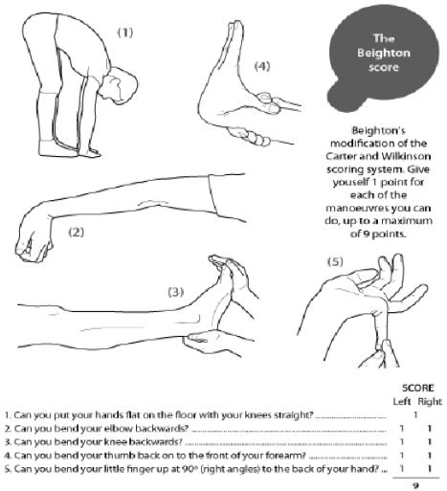
Minor Criteria; have less diagnostic specificity

1) Smooth velvety skin
(2) Molluscoid pseudotumours
(3) Subcutaneous spheroids/spherules
(4) Complications of joint hypermobility
(e.g., sprains, dislocations/subluxations,
pes planus)
(5) Muscle hypotonia, delayed gross motor
development
(6) Easy bruising
(7) Manifestations of tissue extensibility
and fragility (e.g., hiatus hernia, anal
prolapse in childhood, cervical
insufficiency)
(8) Surgical complications (postoperative
hernias)
(9) Positive family history

NOTES
Skin is hyperextensible if it can be stretched over a standardized cut off in the following areas: 1.5 cm for the distal part of the forearms and the dorsum of the hands; 3 cm for neck, elbow and knees; 1 cm on the volar surface of the hand (palm).
Abnormal scarring can range in severity. Most with cEDS have extensive atrophic scars at a number of sites. A minority are more mildly affected. The relevance of surgical scars should be considered with caution in classical EDS, they can appear normal in patients with classical EDS if well managed. Atrophic surgical scars can be found in the general population due to mechanical factors and site of the incision.
Joint hypermobility is evaluated according to the Beighton score; a Beighton score of >5 is considered positive for the presence of generalized joint hypermobility. Since joint hypermobility decreases with age, patients with a Beighton score <5/9 may be considered positive based on their historical observations.
A final diagnosis requires confirmation by molecular testing. More than 90% of those with cEDS have a heterozygous mutation in one of the genes encoding type V collagen (COL5A1 and COL5A2). Rarely, specific mutations in the genes encoding type I collagen can be associated with the characteristics of cEDS. Classical EDS is inherited in the autosomal dominant pattern.

Genetic testing for EDS is currently not supported by Telford and Wrekin CCG, nor the NHS in general.

Management of hypermobility and EDS is around improving muscle control to prevent joint subluxations and dislocations.

Patients are more likely to suffer from Chronic Pain Syndromes and fibromyalgia type complaints and a referral to the Pain Service may help.

Useful patient information is available at https://www.versusarthritis.org/about-arthritis/conditions/joint-hypermobility/

Challenging OsteoArthrits and Changing Health
A team of enthusiastic musculoskeletal physiotherapists at the Princess Royal Hospital, Telford have successfully developed an education and exercise programme for people to manage osteoarthritis of their knees or hips.  The team pictured below consists of Physiotherapists, Amy Haines-Eynon and Nikki Chettle, with Jan Williams and Tracey Harris (Therapy Technicians). The team piloted a programme for a large patient population who commonly struggle to manage their symptoms.  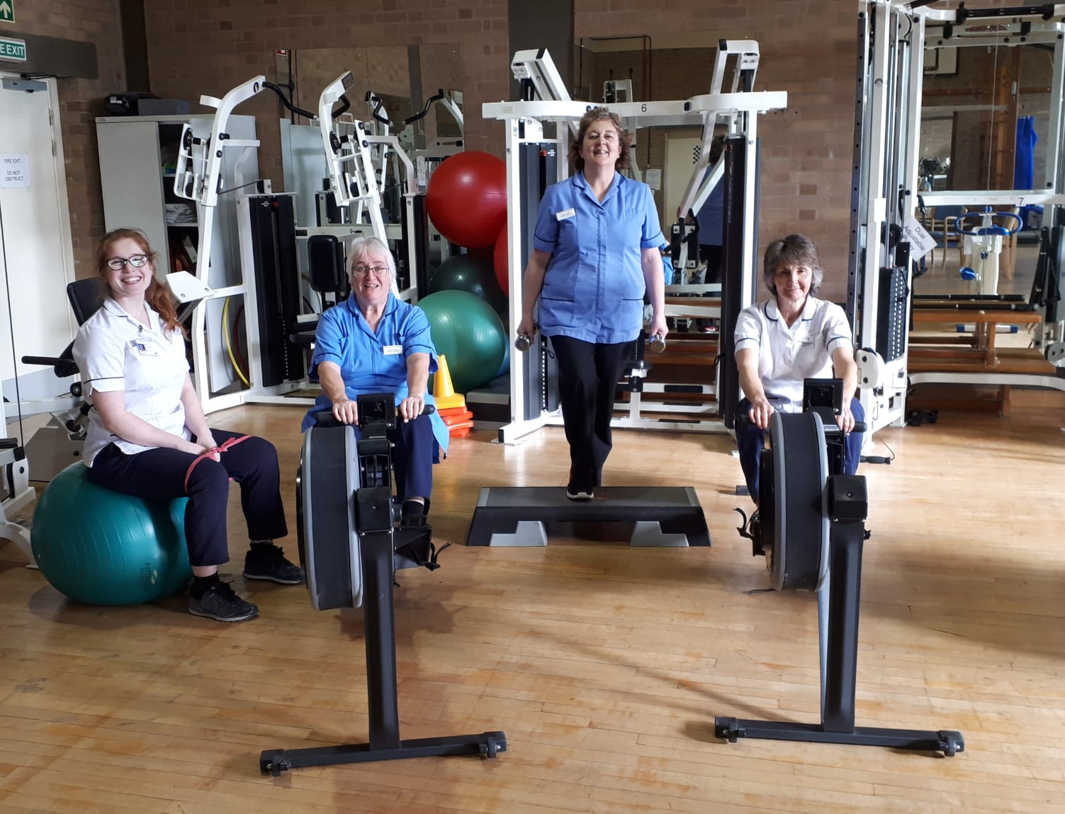  The classes run over a six-week period, with one session per week consisting of an education element along a progressive exercise programme in line with the NICE guidelines for Osteoathritis (2014). Patients attending the classes are entitled to a parking subsidy.  Education sessions consist of; Understanding of Osteoarthritis, Pain, Lifestyle, Medication, Self-management and Managing flare ups. Telford and Wrekin Council Local Health Trainers also attend the sessions, encouraging people to make long term changes to their lifestyle. | Referral process through TeMS  The department works in partnership with the Telford Musculoskeletal Service (TeMS).  SaTH working closely with the TeMS clinical management team to streamline access to the group.
As a result patients have a;
Subjective change in attitude and approach to managing their symptoms
55% meet the minimally clinical significant difference on Keele University’s MSK-HQ questionnaire.
Functionally, 51% of patients are meeting the minimally clinical significant difference for the sit to stand test.
44% of patients are satisfactorily discharged directly from the class
39% are given an independent exercise circuit in our well-equipped gym at the PRH, with follow up from an experienced physiotherapist.

Nikki says;
“what the results show are that patients are starting to make positively significant changes in a short space of time, which we hope will be carried over into the community through linking in with our local health trainers”.

Amy says;
“we see the class as an interim intervention where we look to start to change patients behaviour positively towards management of their condition with options to put their new found knowledge into practice”

Patients have commented on;
“ the benefit of discussing my symptoms with other people with a similar condition”
“the positive power of reassurance that I can do more activity without damaging my joints”

The next steps:
The pilot has been continued given the positive pilot results.
The programme will be further developed in line with the Escape Pain programme.

Sub-acromial Decompression; SAD

A recent BMJ review article about SAD does not recommend operative treatment for shoulder impingement.

Practice Rapid Recommendations

Subacromial decompression surgery for adults with shoulder pain: a clinical practice guideline
BMJ 2019; 364 doi: https://doi.org/10.1136/bmj.l294 (Published 06 February 2019) Cite this as: BMJ 2019;364:l294

How this guideline was created A guideline panel including patients, clinicians, and methodologists produced this recommendation in adherence with standards for trustworthy guidelines and the GRADE system. The recommendation is based on two linked systematic reviews

Abstract
Clinical question Do adults with atraumatic shoulder pain for more than 3 months diagnosed as subacromial pain syndrome (SAPS), also labelled as rotator cuff disease, benefit from subacromial decompression surgery? This guideline builds on to two recent high quality trials of shoulder surgery.
Current practice SAPS is the common diagnosis for shoulder pain with several first line treatment options, including analgesia, exercises, and injections. Surgeons frequently perform arthroscopic subacromial decompression for prolonged symptoms, with guidelines providing conflicting recommendations.
Recommendation The guideline panel makes a strong recommendation against surgery.

