Local Transformation of Maternity Services Update

Baby Buddy
The LMS Programme Board has agreed to fund the localisation and implementation of the ‘Baby Buddy’ app. This app and website has been funded by the Department of Health. Baby Buddy is the multi-award winning free app that guides you through pregnancy, birth, parenting and beyond. https://www.bestbeginnings.org.uk/baby-buddy
Baby buddy vision is for every child in the UK to have the best start in life. It covers many areas such as:
- Being healthy inc. smoking, alcohol, perinatal mental health, drugs, breastfeeding, exercise etc…
The app is readily available to download to anyone and we would ask that should you have any contact with expectant women, please could you advise them of the app.
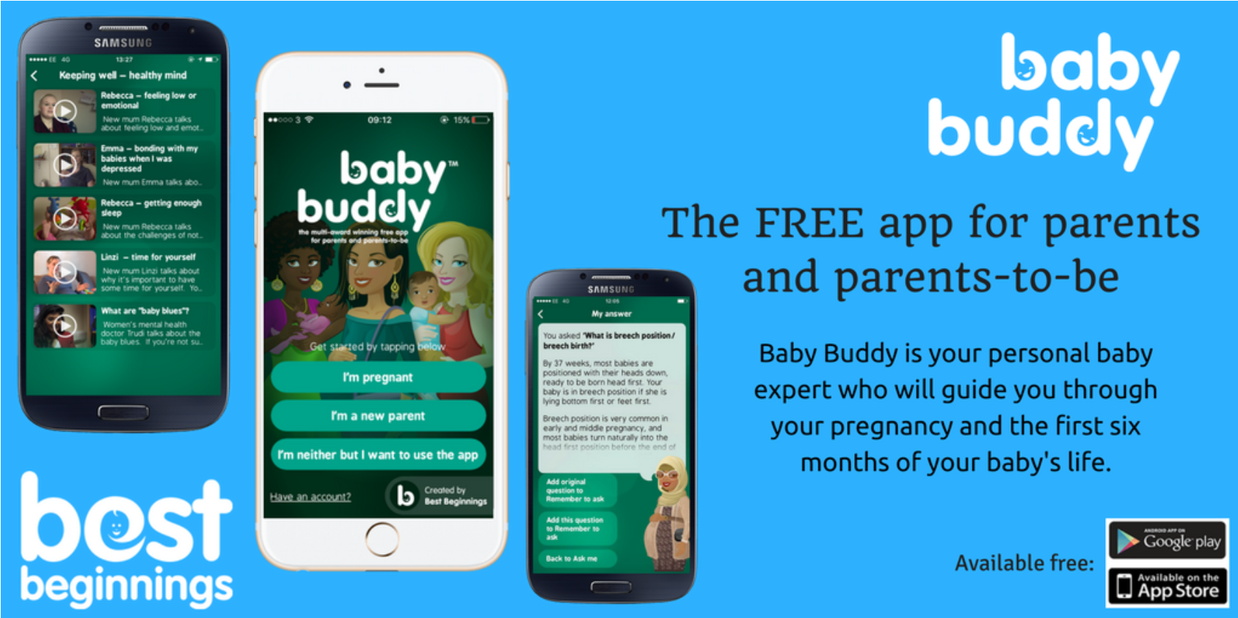
Two Baby Buddy Champion workshops took place on 11th and 13th December 2018 for front line staff to receive training on how to use the app. The sessions were really positive and we now have 33 champions across the LMS. The Project Support Officer is now working closely with them to embed the app into everyday lives and to promote as widely as possible.
Should you wish to receive training on the app please contact helen.white12@nhs.net who will arrange a short session at your practice.
Leaflets, posters and banners are being disseminated and a video of the app has been shared with GP’s to display on their screens. A social media campaign targeting women between the ages of 18 – 45 will commence on 18th Feb 2019 for 4 weeks. Champions will now start training colleagues and informing women of the app wherever possible.
We also have 4 Baby Buddy banners that are currently out at Maternity Units promoting the app. It would be really useful if those banners could rotate around GP Practices for a couple of weeks at a time. If you are willing to display a banner for us then please contact helen.white12@nhs.net

The LMS has funded the app to be localised and GP practices have already been uploaded, however if you have any further information that may be useful to women and their families please can you contact helen.white12@nhs.net who will arrange for the information to be included on the app.
Best Beginnings have also provided us with a short video introducing the app. We would be grateful if could play this on your display screens in the practices if you are able to.
Baby Buddy Infomercial.mp4
https://drive.google.com/file/d/1BOfsESHDz8s9LJ1IagkaSzLiRFDkx9m6/view

Reduced Fetal Movement Awareness
One of the key focuses of the LMS is to ensure women understand what to do if they experience reduced fetal movement or a change to a baby’s normal pattern. The LMS has commissioned Tommy’s to launch a local campaign and should have received a pack from them asking you to display posters and leaflets in your practices. We would be grateful if you could action this as soon as possible to help support our campaign. In addition to this they have provided us with 4 banners which are currently rotating around Maternity Units, however we would like to display them out in the community in the future. If you are willing to display a small banner in your premises for a couple of weeks then please contact helen.white12@nhs,net who will arrange one to be delivered. The LMS has also commissioned a small social media campaign which will be launch on the 21st January 2019 targeting women between the ages of 18 – 45 within a 35 mile radius of Shrewsbury for a week period with their videos on reduced fetal movement.
All practices have been previously asked to share this video released by Tommy’s onto their display screens where possible to raise awareness. We would be grateful if you could support us by sharing this information if you have not already done so. To obtain the video’s please contact helen.white12@nhs.net.
Other initiatives are currently being scoped up which will be launch later this year.

Smoking in Pregnancy Campaign
Smoking in pregnancy rates across Shropshire, Telford and Wrekin are on the rise and so the LMS has commissioned the Lancashire and Midlands Commissioning Support Unit to launch a local Smoking in Pregnancy campaign where they will engage with local women and their families to explore smoking behaviours, perceptions of smoking during pregnancy and triggers to change smoking behaviours. This will then help to develop a local campaign to help encourage local families to go smoke free.

We are looking for local service users who are currently pregnant and are smokers/vapers or service users who managed to stop smoking whilst they were pregnant. If you know anyone who would like to take part in this specific project then please contact helen.white12@nhs.net

Perinatal Mental Health
Following a successful funding bid, Perinatal Mental Health work has commenced to recruit additional staff into a significantly improved Perinatal Mental Health service. The team is expected to be in place by April 2019.

LMS Staff Newsletters
To view December 18 and January 19 staff LMS updates please click on the following:-

Training
The LMS has received funding from Health Education England to enable us to deliver Motivational Interviewing training to all staff across the Shropshire, Telford and Wrekin LMS. Motivational interviewing is a style of communication that uses a guiding/reflective style to engage with patients, clarify their strengths and aspirations, and utilise their own motivations for change, and promote independence of decision making. This training is available for all GP’s to attend should this be of interest to you. I have attached the flyer for further information on dates, venues and further details of the training.
To register a place please contact helen.white12@nhs.net

Transformation Team
Rachel Clorley has joined the LMS Transformation Team in the role of a Maternity Champion to support the Transformation midwife with a number of projects, mainly focusing on Continuity of Carer. Rachel will be working as a champion one day per week for 12 months.
Should you wish to speak to the team for any further information please don’t hesitate to contact us using the information below.

Fiona Ellis - Programme Manager fiona.ellis3@nhs.net
Helen White - Project Support Officer helen.white12@nhs.net
Chris Morris - Senior Responsible Officer Christine.morris19@nhs.net
Maggie Kennerley - Transformation Midwife Maggie.kennerley1@nhs.net
Louise Macleod – Maternity Voices Development Co-ordinator louise.macleod5@nhs.net
Rachel Clorley – Maternity Champion Rachel.clorley@nhs.net

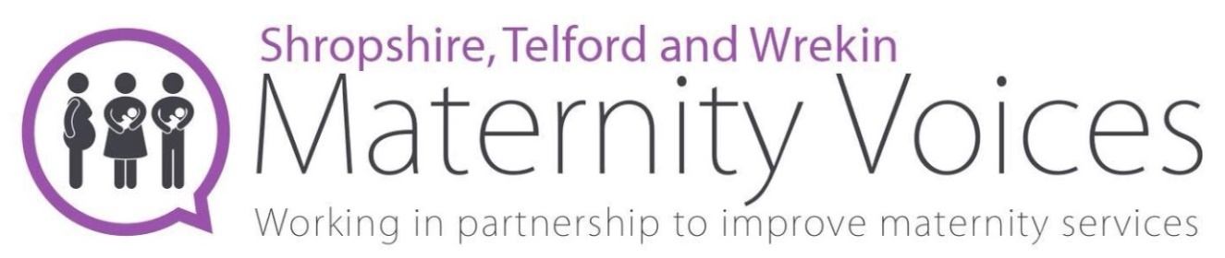

We need your assistance to help promote our local MVP and inform women and their families how they can get involved should they wish to. We are also keen to get staff involved in the MVP and the events that we run. If you would like to be involved further or then get in contact with louise.macleod5@nhs.net

To view a full update on the MVP work that is being undertaken please click on the link below.
http://online.fliphtml5.com/byeza/nrtf/

Check out our new Facebook Page - https://www.facebook.com/MaternityVoicesShropTW/

Or search @MaternityVoicesShropTW

Find us on Twitter @MVP_Shrop_TW

It would be great if you could get involved

Midwife-Led Unit review
Update
On 24th October 2018 a Midwife Led Unit Stakeholder briefing took place where a number of health professionals, women and their families attended. The meeting was designed to cover the rationale for the review, what’s happened so far to bring everyone up to date, what the evidence tells us and describe the vision for the future.
To view the full press release regarding this event please use the link below.
https://www.shropshireccg.nhs.uk/news/five-maternity-hubs-proposed-to-transform-maternity-services-in-shropshire-and-telford-wrekin/?fbclid=IwAR1UStAvxjJgXKb1i7HK7EBQ1N_z_JiS9_9NTzNeKiw8QzR5BwCepv-vZcg

Next steps
We are currently refining our proposals following stakeholder feedback and anticipate that, subject to CCG approval and NHS E Assurance, consultation will commence later this year.

