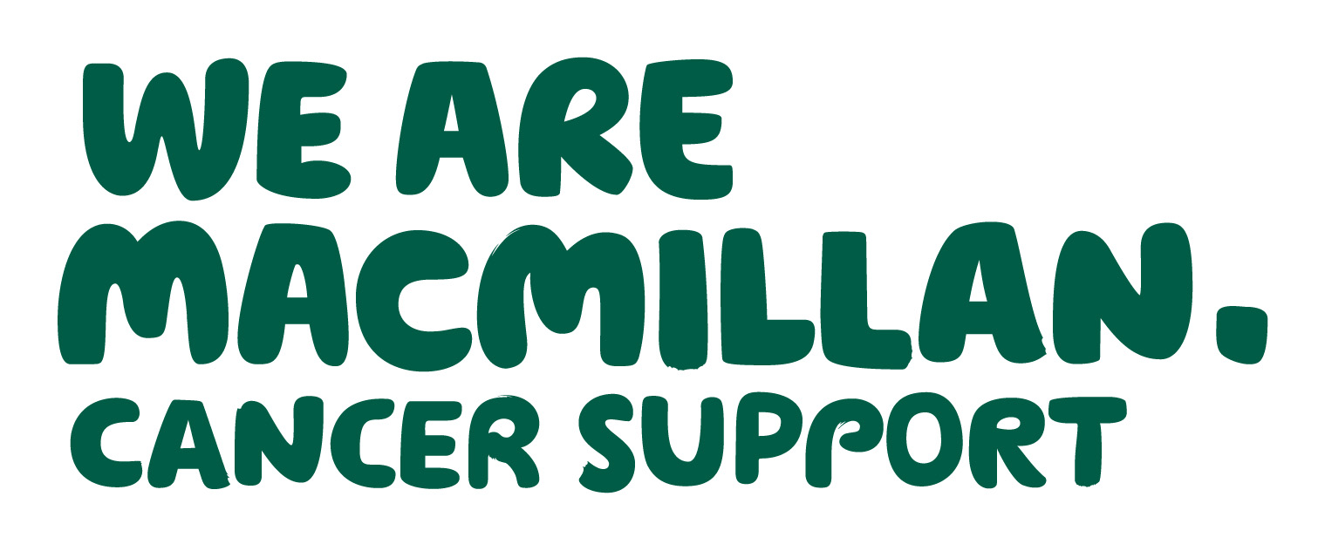 2 MINUTE CANCER UPDATE
December 2018

– keeping you in touch with local and national news
Produced by Dr Gill Clements (Shropshire) and Dr Ellen Nolan (T&W) - your local Macmillan GP facilitators

PALLIATIVE CARE PATIENTS – PLEASE FLAG THEM
We are moving into that slightly crazier time of year – busy, overstretched services, holiday shut downs etc etc. It is therefore important to protect some of your most vulnerable patients by flagging them to 111 and Shropdoc. Out of hours (Shropdoc and 111) still do not have access to important information in EMIS/Vision systems etc, this is why flagging is so vital. When flagging a patient you need to consider what you would want out of hours services to know about them e.g. Diagnosis, prognosis, current treatment/medication? DNAR in place? Preferred place of death? JIC meds in place? Contact details for next of kin?
Flagging your patients will also help avoid an inappropriate response from 111 (eg 999 call out). Please advise your patient/carer/relative, when calling 111 for help, to tell the call handler the diagnosis and relevant details of the condition This, with the flagging notes, will ensure that the call is managed efficiently and passed promptly to the most appropriate service e.g. district nurse or Shropdoc. Details about how to flag your patients in the practiced are included in the document below.
For District Nurses, Hospice and hospital staff – you will need to contact the patient’s practice to ensure that the patient is flagged. If the practice is closed (evenings, weekends and bank holidays) then clinical information can also be shared with Shropdoc via email (shropdoc.flagging@nhs.net). This should only be used if it is not possible to flag via EMIS/Vision otherwise the patients notes will not be included in their practice medical record. Shropdoc also provides a dedicated line for all healthcare professionals – 01743 454903 (available OOHs only). This line is for healthcare professionals attending EOL/palliative care patients with any clinical issue and whose care plan calls for Shropdoc to be contacted OOHs.

