Newsletter
PRIMARY CARE
October 2018
New Physio Pain Programme

TEMS has introduced a new physio-led pain clinic for patients with widespread pain and early fibromyalgia.
The service is run by Martin Black, Kathy Davenhill and Sarah Sutherland with appointments held at both Princess Royal Hospital and Newport Physiotherapy Department.
Please continue to refer patients into TEMS as usual and appointments in the Pain programme will be arranged as necessary.
The programme involves a comprehensive assessment of symptoms and advice on management from pacing to exercise.
We do not prescribe medication or advise on medication dosage.
Outcomes so far have been excellent ; we are using the newly developed MSK –HQ to assess patients before and after treatment.
https://www.keele.ac.uk/pchs/implementingourresearch/makinganimpact/musculoskeletalpain/msk-hqhealthquestionnaire/

The existing pain service run by Pain Management Solutions (now InHealth) continues to operate and we still refer patients to them for more complicated presentations.

ESP NEWS
Heidi Kempner one of our experienced extended scope practitioners has been undergoing training in ultrasound assessment of the shoulder. She recently passed her course assessment with flying colours and will now be using her skills to assess patients with shoulder pain.
She will be working alongside Richard Fallows and Gordon Lumsden who also provided ultrasound assessment and US guided injections.
She is now starting training to give ultrasound guided injections.
GP with Special Interest
Dr Gaynor O’Grady has been working with us now for twelve months; she is a GP with a special interest in Sports Medicine and was working at Severnfields Medical Centre in Shrewsbury before taking up her MSK interest with us. She now works at Westbury part-time and is with us once a week.
We are very pleased to have her as part of the team.
……………………………………………………………………………………………………………………


OCTOBER 17th and 18th 2018; NCE , Birmingham.
For those of you attending I will be chairing a Primary Care MSK session with talks on back pain, diagnosis of spondyloarthritis and OA on Wednesday 17th October. Look forward to seeing you there!

Upcoming National Conference


Primary Care Rheumatology Society Conference 2018
"Improving MSK Medicine & Rheumatology"
Starts: Thursday, 22 November 2018 - 09:00
Ends: Saturday, 24 November 2018 - 13:00
Open the conference poster (PDF) for a summary of the event's lectures and workshops.
Special Joint Injection Session (Pre-booked)
with speakers Drs Alan Walker, Arthur Mone, Simon McGraw and Ms Kirsty Smith.
Delegate booking:
Venue: Park Inn Hotel, North Street, York, YO1 6JF
Download this year's event programme and booking application form (both PDF).
Visit the pcrsociety.org events page for more details.

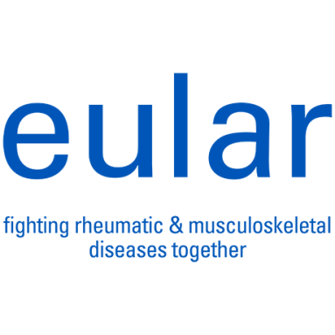

EULAR updates hand osteoarthritis management document

On 6 September 2018, The European League Against Rheumatism (EULAR) published an update to a set of recommendations for the management of hand osteoarthritis. The recommendations report on new evidence made since a first EULAR report was published in 2007.
See the press release (opens in PDF) for the five overarching principles and ten recommendations that were agreed upon in the EULAR

Louise Warburton
10.10.18

