A 21st century Ophthalmology service for Shropshire
Looking to the future
David Sandbach 28th April 2017
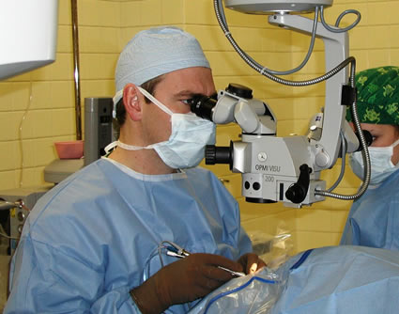

Introduction
At the SaTH Board meeting on 27th April 20017 the following policy was approved:
“Recommendation:
The Trust Board is asked to consider and approve, subject to involvement and consultation requirements:
- The relocation of Paediatric Ophthalmology Outpatients from Clinic 10 RSH to the Copthorne building (Ward 16) for and as interim measure to move all paediatrics to MTX, PRH from 26 May for 12 weeks;
- To withdraw all Ophthalmology services from ICAT, Euston House so as to reduce the current number of operational sites, initially to two and, pending consultation, to reduce to one;
- Agree to engage with the public and consult on one site working to implement ahead of the Future Fit outcome, with specific focus on the one-site outpatient issue which is outside the current Future Fit assumptions.”

If the SaTH Trust Board wants to centralise all Ophthalmic services onto one site it should, as part of its policy proposals noted above, consult on a centralised standalone service located in central Telford as soon as possible.

Proposal:-
Centralise all adult and paediatric out-patient and day surgery services in a leased standalone unit in central Telford.

Cont
The Business case:
On the 6th March 1819 the Eye & Ear Dispensary (the ninth such dispensary in England at the time) opened its doors in the home of a surgeon called Mr G.D.F. Evans in Windsor Place, Shrewsbury. The facilities were a room 17 feet square used as a waiting, consulting and treatment area. Surgery was carried out in a “well lit attic”.
By 1849 the Eye & Ear Dispensary had lost local financial support and was in a “degenerate” state. The service struggled on and in 1867 the fortunes of the Eye & Ear Dispensary were turned around when £400 was raised to buy 9 Dogpole (a former reformatory for prostitutes) eventually this site was expanded and housed the Ear, Eye and Throat Hospital.
It is clear from the SaTH Board papers that the Ophthalmic services in Shropshire are going through a bad time. Is history repeating itself?
The quality of the service has, over the years, degenerated to what has been described by SaTH management as a service which is “extremely challenged in a number of areas, namely workforce, accommodation, service delivery and waiting times including increasing past maximum waits.”
What the data says
The data below indicates where Shropshire stands in relation to a National and local Referral to Treatment Time (RTT) context.
England
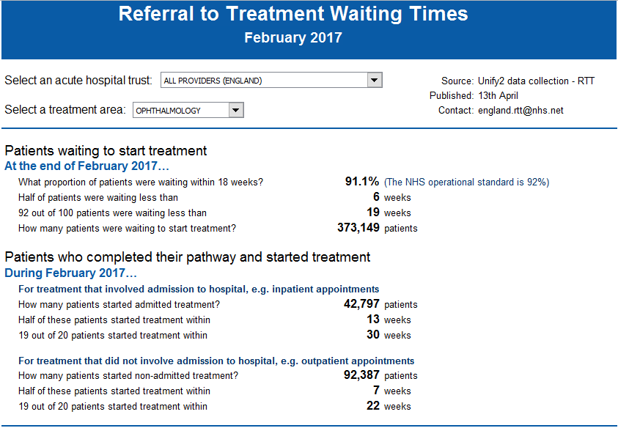
Shropshire
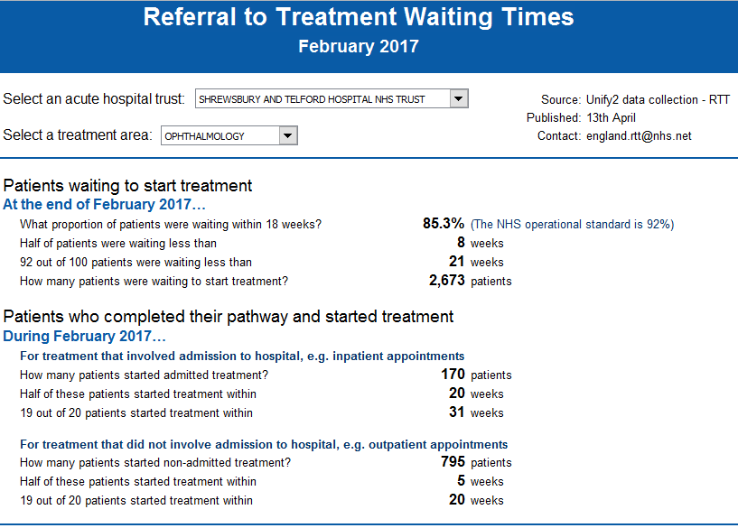

Wolverhampton
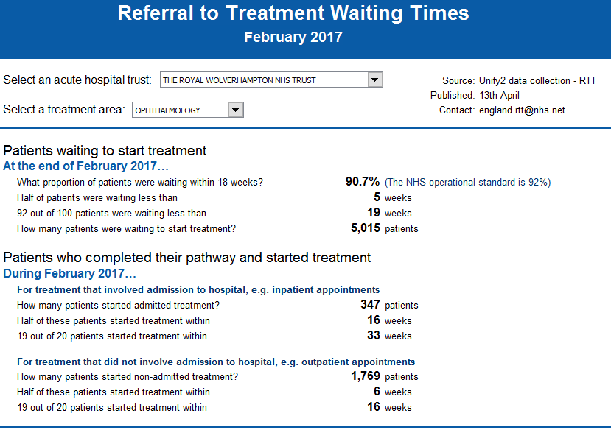

Dudley
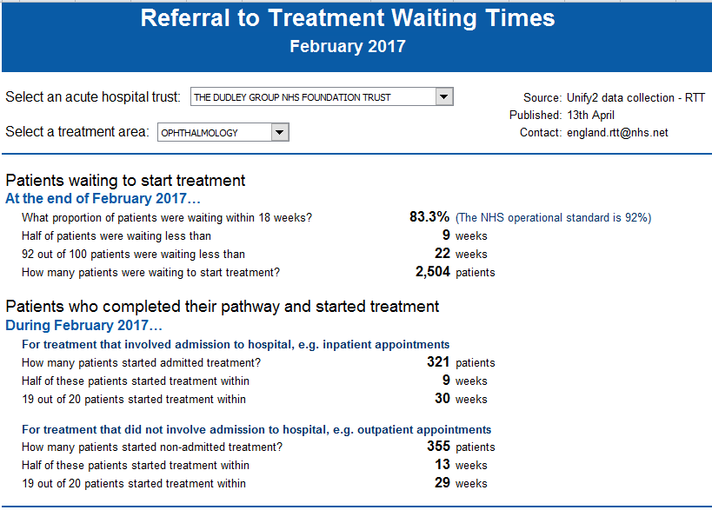

North Midlands
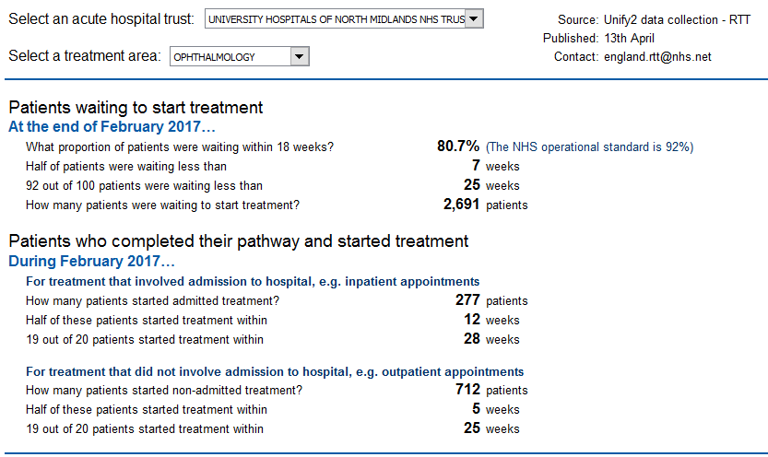
What these figures tell us is that Ophthalmology generates plenty of demand and many organisations are poor at achieving the RRT standard – one exception is Moorfields Eye Hospital NHS Foundation Trust.

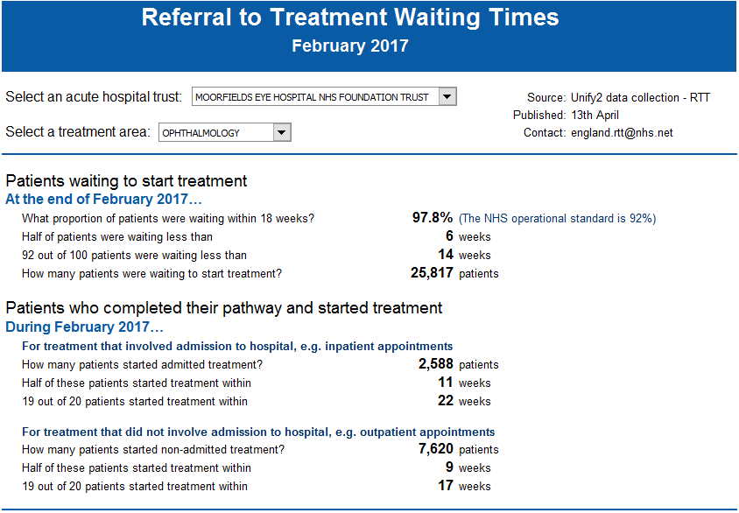

So the question we have to ask ourselves around here is “can we turn things round and get to a 99% RTT situation?”

If SaTH took the following steps as outlined below there may be a sporting chance that we could get to a percentage RTT outcome very near to the one achieved by in Moorfields Eye Hospital.

Cont

Action

- Lease Partnership House, Central Park, Telford Shropshire TF2 9TZ.

This property is a detached three-storey office building extending to 3,206 m² built in 1992 / 93. It has two 10 person passenger lifts, UPS generator and air handling system. It is approached from a mini-roundabout surrounded by a landscaped car park providing 207 car parking spaces. The property is close to the main railway station.

- Install two theatres, clean and dirty utility rooms, one children’s out-patient area and one adult’s out-patient area plus administration offices, training room facilities, clinical quality video conferencing facilities and a staff room.

Financials
Estimated - subject to negotiation.
Rental circa £100 per annum per m² x 3,206 = £320,600
Business Rates pa £252,500
Heat light power pa est. £80,000
Estimated annual cost of occupation pa = £653,000

The plan approved by the SaTH Board indicates that a single site solution based at PRH would have a capital cost of £4.14 million this would require an annual revenue commitment of circa £414,000 pa.
These ball park figures are close enough to merit further detailed work and refinement as part of an Outline Business Case financial evaluation process.

Questions and answers:

Q What can you get into 3,206 m²?
A
To get some idea it is worth noting that each cruciform at PRH measures 1066 m².
A cruciform contains 2 wards with28 beds per ward. So for comparative purposes the Partnership House property has six wards worth of space.

Q How long would it take to refurbish and organise things?
A
Post public consultation around 4 months max 5 months.
The space inside the building is easy to configure and can easily accommodate various to operational zones and service needs. Because the building exists the principle of co-production between NHS staff and patient representatives can be achieved by physically marking out areas and adjusting room dimensions and activity zone relationships.

Q Where is the capital to refurbish coming from?
A
There are several options e.g. transformation funds under the STP program or negotiate with the owners of the building to carry out the refurbishment (to a SaTH specification).
The owners get their additional investment back by charging a higher rent over the period of the lease.

Cont
Q Is a franchise deal worth considering?
A
Yes – the obvious franchise deal would be with the Moorfields Eye Hospital in London. The new service brand name would be say “Moorefields in Shropshire” or “The Moorfields Midlands Cataract Centre”.
The deal would involve a partnership with an internationally renowned eye hospital.
It would involve:
- Joint clinical governance and standard setting.
- Joint training programs for doctors, nurses and allied health professionals possibly with some capacity for rotational placements.
- Joint research programs.
- Joint appointments e.g. Professors, specialist surgeons.
- Digital connectivity facilities e.g. virtual or robotic surgery potentials.
- Tertiary referrals to Moorfields for a small number of cases presenting at the unit.
- A small payment to Moorfields per finished consultant episode.

Q Would a stand-alone Eye Unit attract staff?
A
Yes. Clinical “young guns” doctors, nurses and allied health professionals would all see this kind of development as “something to be part of” because of the innovative operational model inherent in this kind of set up.
This is especially so if a franchise deal can be done with Moorfields. Staff especially junior staff get the benefit of association with a specialist tertiary London Hospital and the associated reflected “professional kudos” without the expense of living in London.

Cont
Q What is the production breakeven point?
A
Difficult to say depends on how much work is sucked in to Shropshire from out of county – estimated population catchment numbers is 2.5 - 3 million people and the natural rise in demand from within Shropshire.

Q What is the risk involved?
A
1) SaTH stagers on making slow (ish) progress and some other Trust or private sector organisation opens up out-reach Ophthalmology clinics in Shropshire making off with a lot of discontented Shropshire patients willing to travel out of county for their eye operation.
2) If this plan is agreed and the market demand does not expand and the Trust is left with a £240,000 turnover shortfall.

Q Should SaTH take all the financial risk?

A

No. The benefits of this venture will accrue directly and very quickly to Shropshire residents and NHS service commissioners in Shropshire i.e. Shropshire CCG and Telford & Wrekin CCG.

As such the benefits and risk associated with this new business model should be shared on an equal three way basis.

Cont
Q Will this initiative deliver 7 day working?

A

Yes. The facility is effectively a medical “factory” available 168 hours per week.

Like all factories it can be used on a seven day cycle.

In theory it could deliver NHS work on a 7 day x 12 hour basis and then switch into an international health care provider facility. Funding for this aspect of service could come from the Department of Overseas Aid and or international charities.

Spare capacity could be used to provide a private patents service.

Q Will this plan skew the Future Fit options.

A

No. There are no really significant interdependences involved i.e. it does not matter to this service where ED is. The skills at this unit can be delivered to the ED using video conferencing and the out of hours arrangements in operation at the moment would continue as now.

Final observation
We know what our predecessors did in 1867 in order to correct the desperate situation they found themselves in.
The question is “do we have the ambition and determination that they had to turn round our Ophthalmology service and make it fit for the 21st century?
How hungry for operational service success around here are we?

David Sandbach.
28th April 2017.

https://www.sath.nhs.uk/wp-content/uploads/2017/04/06-Ophthalmology-Service-Developments.pdf
Further details contact Mr N. Dixon www.andrew-dixon.co.uk 01952 52100
I have seen this approach in a service design laboratory in Denmark. It works very well giving a tailor made culturally acceptable service environment as an end result.
http://www.ox.ac.uk/news/2016-09-12-world-first-robot-eye-operation
https://www.youtube.com/watch?v=W7mHbpnDoPQ

